BEGUM ROKEYA UNIVERSITY, RANGPUR



Department of Computer Science & Engineering

**Course Title:** Microprocessor and Assembly Language

**Course Code:** CSE 3205

**Assignment On: Lab Report-01 On Assembly Codes**

|  |  |
| --- | --- |
| **Submitted By**, | **Submitted To,** |
| MD. Jubayer Hossen Jame  ID: 1605006  3rd Year 2st Semester  Session: 2016-17  Department of Computer Science and Engineering | Marjia Sultana  Lecturer  Department Of Computer Science & Engineering.  Begum Rokeya University, Rangpur |

**Submission Date:** 19 December, 2021

**; 1. A Simple assembly code to take a input (a number/character/string) from keyboard and print the input.**

.model small ;model directory <-- Specifies the total amount of memory the program would take

.stack 100h ;stack segment directory <-- Specifies the storage for stack

.data ;data segment directory <-- variables are defined here

string db 100 dup('$')

msg1 db 'Give the input String $'

msg db 'The input String is.......... $'

.code ;code segment directory

main proc

mov bx, @data

mov ds, bx ;initialize heap memory

;or .startup it will load the data into DS memory

;print the msg1

mov dx, offset msg1

mov ah, 9

int 21h

lea si, string ;same as -> mov si, offset string

input:

mov ah, 1

int 21h

cmp al, 13 ;13 is the ASCII value of enter key

je Display ;conditional jump

mov [si], al

add si, 1 ;same as -> inc si

jmp input ;unconditional jump

Display:

mov dx, offset msg

mov ah, 9

int 21h

;print the string

mov dx, offset string

mov ah, 9

int 21h

;return from ah register

mov ah, 4ch

int 21h

main endp

end main

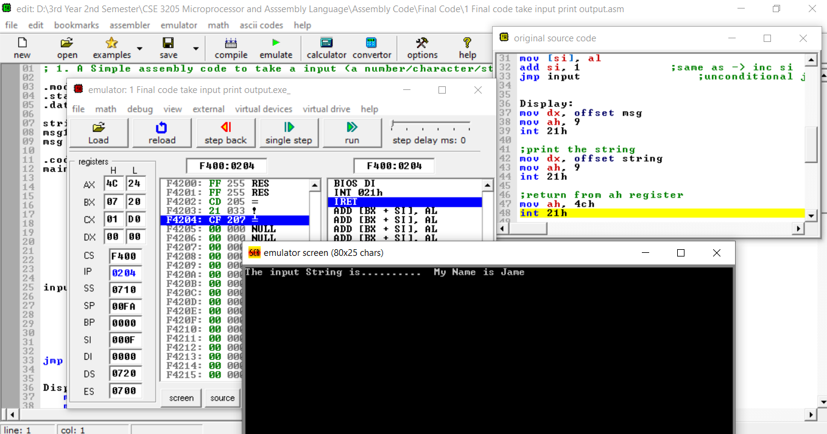

**; 2.Perform addition of two numbers(2 Digit Number)**

.model small ;model directory <-- Specifies the total amount of memory the program would take

.stack 100h ;stack segment directory <-- Specifies the storage for stack

.data ;data segment directory <-- variables are defined here

sum dw 0

cnt dw 3

msg1 dw ' Enter First Number( 2 Digit ).... $'

msg2 dw 13, 10, 'Enter Second Number( 2 Digit ).... $'

endl dw 13, 10, 13, 10, 'The sum is .... $'

counter dw 0

base dw 10

.code ;code segment directory

main proc

mov ax, @data

mov ds, ax

;print the msg1

mov dx, offset msg1

mov ah, 09h

int 21h

mov cx, 0 ;so that cx contain a proper value

takingInput:

add sum, cx

dec cnt

cmp cnt, 0

jnz input2DigitNumber

call Display16bitsNumber

main endp

;***************************************** PROCEDURE *****************************************

;***************************************** *****************************************

input2DigitNumber proc

;taking the first digit

mov ah, 01h

int 21h

sub al, 30h ; 30h = 48 ;ASCII to integer

mov bh, al ; bx = bh bl

;taking the second digit

mov ah, 01h

int 21h

sub al, 30h

mov ch, al ;store the second digit

mov al, bh ;for multi

mov bl, 10 ;bx = bh bl

;= 05 10

mul bl ;8 bits multiplication

;ax = al * 8-bits reg

add al, ch ;al containx num * 10

;al = al + ch

; = 50 + 2

; = 52

mov cx, ax ;bcz in 71 line ax will corrupt

;print the msg2

mov dx, offset msg2

mov ah, 09h

int 21h

jmp takingInput

input2DigitNumber endp

;Printing 16 bit number using stack in 8086 Assembly language

Display16bitsNumber proc

;print the endl

mov dx, offset endl

mov ah, 9

int 21h

mov ax, sum

cmp ax, 0 ;ax < 0

jge repeat ;if ax >= 0 ;for jg 0 result will -0 that is not right ans

;if negative

push ax ;mov ah, 02h e value change hoye jabe

mov dl, '-'

mov ah, 02h

int 21h

pop ax

neg ax ;again 2's compliment so that we can get the proper value

repeat:

mov dx, 0 ; dx = dividend high (To avoid divide overflow error)

div base ; ax = Quotient, dx = remainder

push dx ; push e always 16 bit dite hoy

inc [counter] ;number of digit count

cmp ax, 0

jne repeat

mov cx, [counter]

mov ah, 02h

again:

pop dx

add dx, 30h ;30h = 48;integer to ASCII; character

int 21h

loop again

Display16bitsNumber endp

;for successfully return

mov ah, 4ch

int 21h

end main

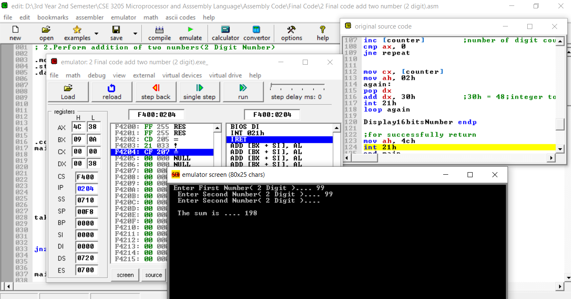

**; 3.Perform subtraction of two numbers(2 Digit Number)**

.model small ;model directory <-- Specifies the total amount of memory the program would take

.stack 100h ;stack segment directory <-- Specifies the storage for stack

.data ;data segment directory

sum dw 0

cnt dw 3

msg1 dw 'Enter First Number( 2 Digit ).... $'

msg2 dw 13, 10, 'Enter Second Number( 2 Digit ).... $'

endl dw 13, 10, 13, 10, 'The subtraction is (First - Second) .... $'

counter dw 0

base dw 10

.code ;code segment directory

main proc

mov ax, @data

mov ds, ax

;print the msg1

mov dx, offset msg1

mov ah, 09h

int 21h

mov cx, 0 ;so that cx contain a proper value

takingInput:

;add sum, ax

cmp cnt, 1

je negativeValue

add sum, cx

dec cnt

cmp cnt, 0

jnz input2DigitNumber

negativeValue:

sub sum, cx

call Display16bitsNumber

main endp

;***************************************** PROCEDURE *****************************************

;***************************************** *****************************************

input2DigitNumber proc

;taking the first digit

mov ah, 01h

int 21h

sub al, 30h ; 30h = 48 ;ASCII to integer

mov bh, al ; bx = bh bl

;taking the second digit

mov ah, 01h

int 21h

sub al, 30h

mov ch, al ;store the second digit

mov al, bh ;for multi

mov bl, 10 ;bx = bh bl

;= 05 10

mul bl ;8 bits multiplication

;ax = al * 8-bits reg

add al, ch ;al containx num * 10

;al = al + ch

; = 50 + 2

; = 52

mov cx, ax ;bcz in 78 line ax will corrupt

;print the msg2

mov dx, offset msg2

mov ah, 09h

int 21h

jmp takingInput

input2DigitNumber endp

;Printing 16 bit number using stack in 8086 Assembly language

Display16bitsNumber proc

;print the endl

mov dx, offset endl

mov ah, 9

int 21h

mov ax, sum

cmp ax, 0 ;ax < 0

jge repeat ;if ax >= 0 ;for jg 0 result will -0 that is not right ans

;if negative

push ax ;mov ah, 02h e value change hoye jabe

mov dl, '-'

mov ah, 02h

int 21h

pop ax

neg ax ;again 2's compliment so that we can get the proper value

repeat:

mov dx, 0 ; dx = dividend high (To avoid divide overflow error)

div base ; ax = Quotient, dx = remainder

push dx ; push e always 16 bit dite hoy

inc [counter] ; number of digit count

cmp ax, 0

jne repeat

mov cx, [counter]

mov ah, 02h

again:

pop dx

add dx, 30h ;30h = 48;integer to ASCII; character

int 21h

loop again

Display16bitsNumber endp

;for successfully return

mov ah, 4ch

int 21h

end main

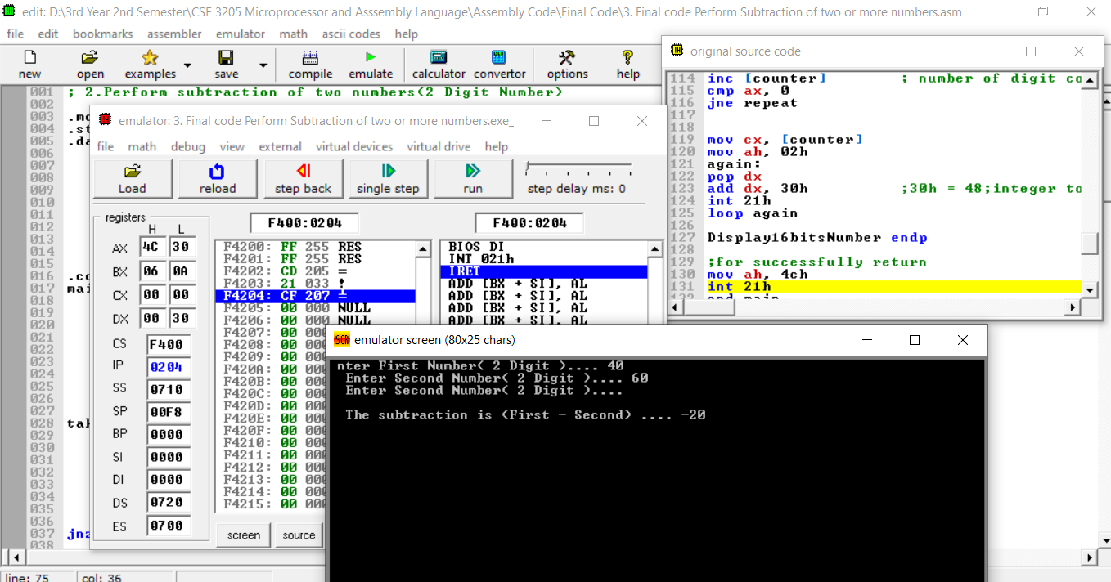

**;4. Case Conversion of a character/ a string**

.model small ;model directory <-- Specifies the total amount of memory the program would take

.stack 100h ;stack segment directory <-- Specifies the storage for stack

.data ;data segment directory

string db 100 dup('$')

msg1 db 'Give the input String ..... $'

msg2 db 13, 10, 'The Output is ..... $'

.code ;code segment directory

conversion proc

mov bx, @data

mov ds, bx

;or .startup

;print the msg1

mov dx, offset msg1

mov ah, 9

int 21h

mov si, offset string

takeInput:

mov ah, 1

int 21h

cmp al, 13 ;13 is the ASCII value of enter key

je Display ;conditional jump

cmp al, 32 ;32 is the ASCII value of space

je space:

cmp al, 96 ;96 is the ASCII value of (a)

jg upper:

jl lower:

jmp takeInput ;unconditional jump

space:

mov [si], al

inc si

jmp takeInput

upper:

sub al, 32

mov [si], al

inc si

jmp takeInput

lower:

add al, 32

mov [si], al

inc si

jmp takeInput

Display:

;print the msg2

mov dx, offset msg2

mov ah, 9

int 21h

;print the string

mov dx, offset string

mov ah, 9

int 21h

;return from ah register successfully

mov ah, 4ch

int 21h

conversion endp

end conversion

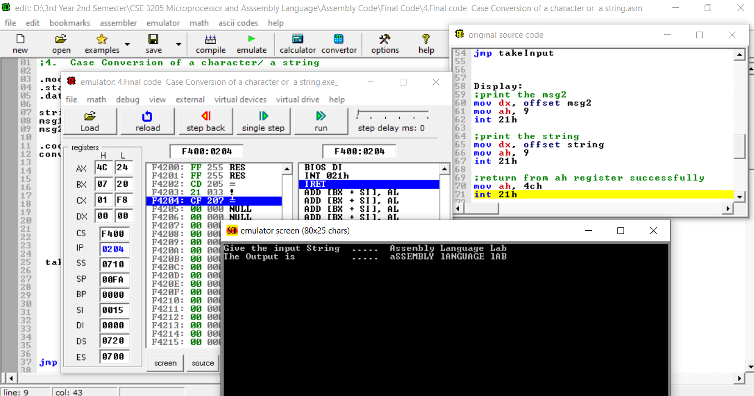

**; 6. Using only MOV, ADD, SUB, INC, DEC, and NEG, translate the**

**;following high-level language assignment statements Into assembly language.**

**;A, B, and C are word variables.**

**;a. A = B - A**

**;Assuming A and B are 2 Digit Numbers**

.model small ;model directory <-- Specifies the total amount of memory the program would take

.stack 100h ;stack segment directory <-- Specifies the storage for stack

.data ;data segment directory <-- variables are defined here

A dw 0

B dw 0

cnt dw 3

msg1 dw 'Enter A ( 2 Digit ).... $'

msg2 dw 13, 10, 'Enter B ( 2 Digit ).... $'

endl dw 13, 10, 13, 10, 'The result of A = B - A is .... $'

counter dw 0

base dw 10

.code ;code segment directory

main proc

mov ax, @data

mov ds, ax

;print the msg1

mov dx, offset msg1

mov ah, 09h

int 21h

mov cx, 0 ;so that cx contain a proper value

takingInput:

cmp cnt, 1

je negative

add A, cx

dec cnt

cmp cnt, 0

jnz input2DigitNumber

negative:

sub cx, A ;cx = B, sum = A so B = B - A

mov A, cx ;bcz in display cx will override

call Display16bitsNumber

main endp

;***************************************** PROCEDURE *****************************************

;***************************************** *****************************************

input2DigitNumber proc

;taking the first digit

mov ah, 01h

int 21h

sub al, 30h ; 30h = 48 ;ASCII to integer

mov bh, al ; bx = bh bl

;taking the second digit

mov ah, 01h

int 21h

sub al, 30h

mov ch, al ;store the second digit

mov al, bh ;for multi

mov bl, 10 ;bx = bh bl

;= 05 10

mul bl ;8 bits multiplication

;ax = al * 8-bits reg

add al, ch ;al containx num * 10

;al = al + ch

; = 50 + 2

; = 52

mov cx, ax

;print the msg2

mov dx, offset msg2

mov ah, 09h

int 21h

jmp takingInput

input2DigitNumber endp

;Printing 16 bit number using stack in 8086 Assembly language

Display16bitsNumber proc

;print the endl

mov dx, offset endl

mov ah, 9

int 21h

mov ax, A

cmp ax, 0 ;ax < 0

jge repeat ;if ax >= 0 ;for jg 0 result will -0 that is not right ans

;if negative

push ax ;mov ah, 02h e value change hoye jabe

mov dl, '-'

mov ah, 02h

int 21h

pop ax

neg ax ;again 2's compliment so that we can get the proper value

repeat:

mov dx, 0 ; dx = dividend high (To avoid divide overflow error)

div base ; ax = Quotient, dx = remainder

push dx ; push e always 16 bit dite hoy

inc [counter] ;number of digit count

cmp ax, 0

jne repeat

mov cx, [counter]

mov ah, 02h

again:

pop dx

add dx, 30h ;30h = 48;integer to ASCII; character

int 21h

loop again

Display16bitsNumber endp

;for successfully return

mov ah, 4ch

int 21h

end main

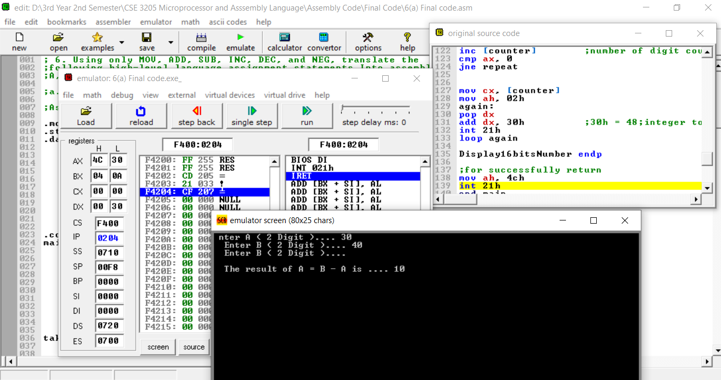

**; 6. Using only MOV, ADD, SUB, INC, DEC, and NEG, translate the**

**;following high-level language assignment statements Into assembly language.**

**;A, B, and C are word variables.**

**;b. A = -(A+ 1)**

**;Assuming A is a 2 Digit Number**

.model small

.stack 100h

.data

A dw 0

cnt dw 3

msg1 dw ' Give the value of A (2 Digit) ... $'

endl dw 13, 10, 13, 10, 'The result of A = -(A + 1) is .... $'

counter dw 0

base dw 10

.code

main proc

mov ax, @data

mov ds, ax

;print the msg1

mov dx, offset msg1

mov ah, 09h

int 21h

mov ax, 0 ;remove @data address

call input2DigitNumber

add ax, 1

neg ax

mov A, ax ;bcz in display ax will override

call Display16bitsNumber

main endp

;***************************************** PROCEDURE *****************************************

;***************************************** *****************************************

input2DigitNumber proc

;taking the first digit

mov ah, 01h

int 21h

sub al, 30h ; 30h = 48 ;ASCII to integer

mov bh, al ; bx = bh bl

;taking the second digit

mov ah, 01h

int 21h

sub al, 30h

mov ch, al ;store the second digit

mov al, bh ;for multi

mov bl, 10 ;bx = bh bl

;= 05 10

mul bl ;8 bits multiplication

;ax = al * 8-bits reg

add al, ch ;al containx num * 10

;al = al + ch

; = 50 + 2

; = 52

ret ;return the line 34

input2DigitNumber endp

;Printing 16 bit number using stack in 8086 Assembly language

Display16bitsNumber proc

;print the endl

mov dx, offset endl

mov ah, 9

int 21h

mov ax, A

cmp ax, 0 ;ax < 0

jge repeat ;if ax >= 0 ;for jg 0 result will -0 that is not right ans

;if negative

push ax ;mov ah, 02h e value change hoye jabe

mov dl, '-'

mov ah, 02h

int 21h

pop ax

neg ax ;again 2's compliment so that we can get the proper value

repeat:

mov dx, 0 ; dx = dividend high (To avoid divide overflow error)

div base ; ax = Quotient, dx = remainder

push dx ; push e always 16 bit dite hoy

inc [counter] ;number of digit count

cmp ax, 0

jne repeat

mov cx, [counter]

mov ah, 02h

again:

pop dx

add dx, 30h ;30h = 48;integer to ASCII; character

int 21h

loop again

Display16bitsNumber endp

;for successfully return

mov ah, 4ch

int 21h

end main

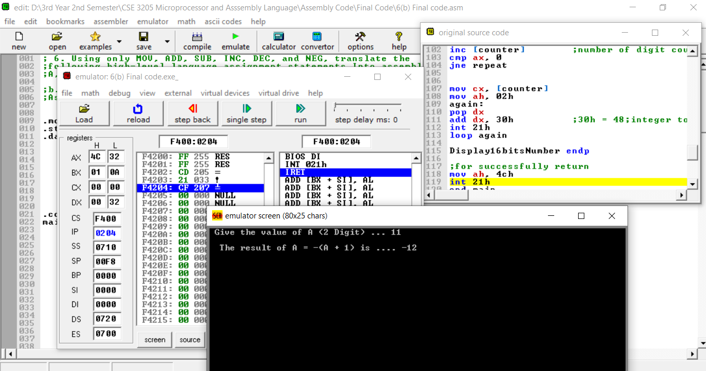

**; 6. Using only MOV, ADD, SUB, INC, DEC, and NEG, translate the**

**;following high-level language assignment statements Into assembly language.**

**;A, B, and C are word variables.**

**;c. C = A + B**

**;Assuming A and B are 2 Digit Numbers**

.model small

.stack 100h

.data

sum dw 0

cnt dw 3

endl dw 13, 10, 13, 10, 'The sum of C = A + B is .... $'

msg1 dw ' Give the value of A and B (2 Digit) ... $'

counter dw 0

base dw 10

.code

main proc

mov ax, @data

mov ds, ax

;print the msg1

mov dx, offset msg1

mov ah, 09h

int 21h

mov ax, 0 ;for remove the 09h

takingInput:

add sum, ax

dec cnt

cmp cnt, 0

jnz input2DigitNumber

call Display16bitsNumber

main endp

;***************************************** PROCEDURE *****************************************

;***************************************** *****************************************

input2DigitNumber proc

;taking the first digit

mov ah, 01h

int 21h

sub al, 30h ; 30h = 48 ;ASCII to integer

mov bh, al ; bx = bh bl

;taking the second digit

mov ah, 01h

int 21h

sub al, 30h

mov ch, al ;store the second digit

mov al, bh ;for multi

mov bl, 10 ;bx = bh bl

;= 05 10

mul bl ;8 bits multiplication

;ax = al * 8-bits reg

add al, ch ;al containx num * 10

;al = al + ch

; = 50 + 2

; = 52

jmp takingInput

input2DigitNumber endp

;Printing 16 bit number using stack in 8086 Assembly language

Display16bitsNumber proc

;print the endl

mov dx, offset endl

mov ah, 9

int 21h

mov ax, sum

cmp ax, 0 ;ax < 0

jge repeat ;if ax >= 0 ;for jg 0 result will -0 that is not right ans

;if negative

push ax ;mov ah, 02h e value change hoye jabe

mov dl, '-'

mov ah, 02h

int 21h

pop ax

neg ax ;again 2's compliment so that we can get the proper value

repeat:

mov dx, 0 ; dx = dividend high (To avoid divide overflow error)

div base ; ax = Quotient, dx = remainder

push dx ; push e always 16 bit dite hoy

inc [counter] ;number of digit count

cmp ax, 0

jne repeat

mov cx, [counter]

mov ah, 02h

again:

pop dx

add dx, 30h ;30h = 48;integer to ASCII; character

int 21h

loop again

Display16bitsNumber endp

;for successfully return

mov ah, 4ch

int 21h

end main

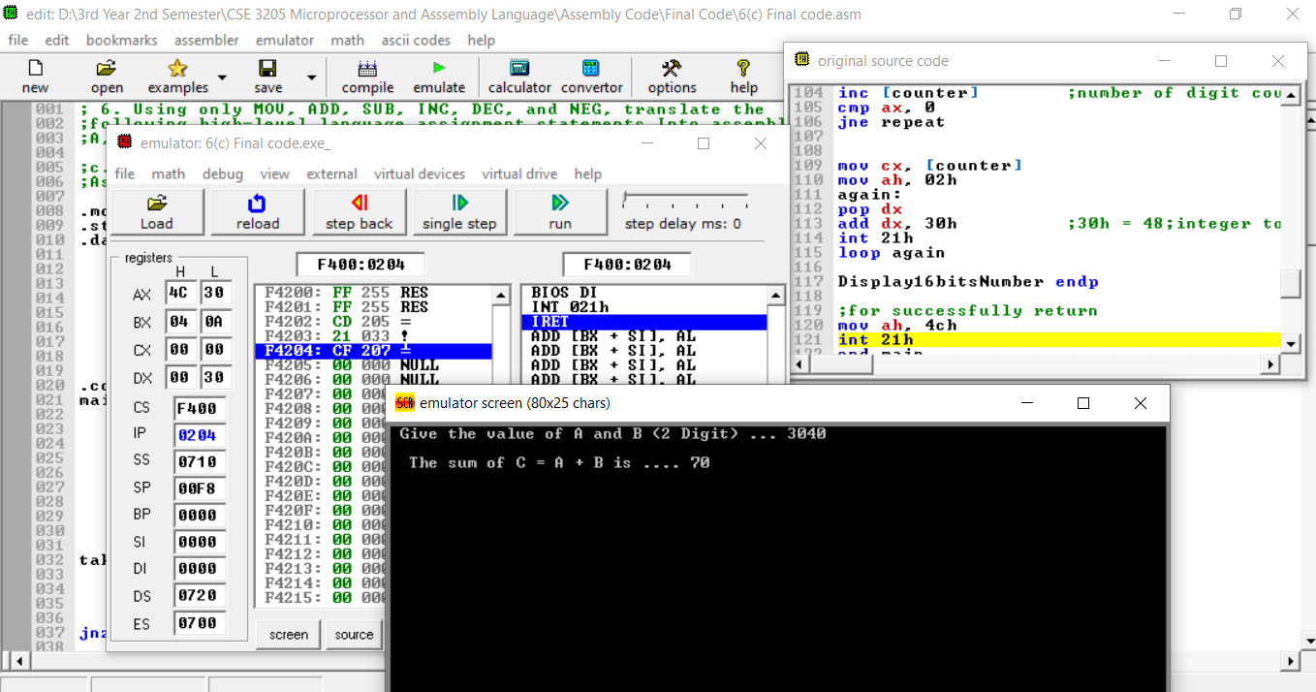

**; 6. Using only MOV, ADD, SUB, INC, DEC, and NEG, translate the**

**;following high-level language assignment statements Into assembly language.**

**;A, B, and C are word variables.**

**;d. B = 3 * B + 7**

**;Assuming B is a 2 Digit Number**

.model small

.stack 100h

.data

B dw 0

cnt dw 3

msg1 dw ' Give the value of B (2 Digit) ... $'

endl dw 13, 10, 13, 10, 'The result of B = 3 * B + 7 is .... $'

counter dw 0

base dw 10

.code

main proc

mov ax, @data

mov ds, ax

;print the msg1

mov dx, offset msg1

mov ah, 09h

int 21h

mov ax, 0 ;remove @data address

call input2DigitNumber

mov B, ax

add ax, B

add ax, B

add ax, 7

mov B, ax ;bcz in display ax will override

call Display16bitsNumber

main endp

;***************************************** PROCEDURE *****************************************

;***************************************** *****************************************

input2DigitNumber proc

;taking the first digit

mov ah, 01h

int 21h

sub al, 30h ; 30h = 48 ;ASCII to integer

mov bh, al ; bx = bh bl

;taking the second digit

mov ah, 01h

int 21h

sub al, 30h

mov ch, al ;store the second digit

mov al, bh ;for multi

mov bl, 10 ;bx = bh bl

;= 05 10

mul bl ;8 bits multiplication

;ax = al * 8-bits reg

add al, ch ;al containx num * 10

;al = al + ch

; = 50 + 2

; = 52

ret ;return the line 34

input2DigitNumber endp

;Printing 16 bit number using stack in 8086 Assembly language

Display16bitsNumber proc

;print the endl

mov dx, offset endl

mov ah, 9

int 21h

mov ax, B

cmp ax, 0 ;ax < 0

jge repeat ;if ax >= 0 ;for jg 0 result will -0 that is not right ans

;if negative

push ax ;mov ah, 02h e value change hoye jabe

mov dl, '-'

mov ah, 02h

int 21h

pop ax

neg ax ;again 2's compliment so that we can get the proper value

repeat:

mov dx, 0 ; dx = dividend high (To avoid divide overflow error)

div base ; ax = Quotient, dx = remainder

push dx ; push e always 16 bit dite hoy

inc [counter] ;number of digit count

cmp ax, 0

jne repeat

mov cx, [counter]

mov ah, 02h

again:

pop dx

add dx, 30h ;30h = 48;integer to ASCII; character

int 21h

loop again

Display16bitsNumber endp

;for successfully return

mov ah, 4ch

int 21h

end main

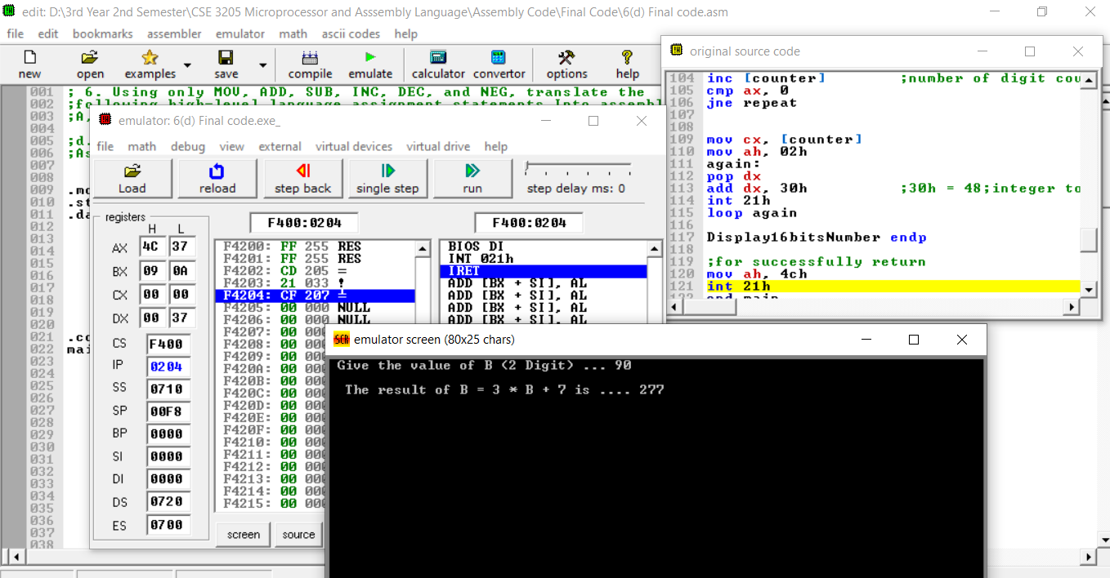

**; 6. Using only MOV, ADD, SUB, INC, DEC, and NEG, translate the**

**;following high-level language assignment statements Into assembly language.**

**;A, B, and C are word variables.**

**;e. A = B - A - 1**

;Assuming A and B are 2 Digit Numbers

.model small

.stack 100h

.data

A dw 0

B dw 0

cnt dw 3

msg1 dw ' Give the value of A (2 Digit) ... $'

msg2 dw 13, 10, 'Give the value of B (2 Digit) ... $'

endl dw 13, 10, 13, 10, 'The result of A = B - A - 1 is .... $'

counter dw 0

base dw 10

.code

main proc

mov ax, @data

mov ds, ax

;print the msg1

mov dx, offset msg1

mov ah, 09h

int 21h

mov cx, 0 ;for remove garbage value

takingInput:

cmp cnt, 1

je inputB

add A, cx

dec cnt

cmp cnt, 0

jnz input2DigitNumber

inputB:

sub cx, A ;cx = B, sum = A so B = B - A

mov A, cx ;bcz in display I will use A

dec A

call Display16bitsNumber

main endp

;***************************************** PROCEDURE *****************************************

;***************************************** *****************************************

input2DigitNumber proc

;taking the first digit

mov ah, 01h

int 21h

sub al, 30h ; 30h = 48 ;ASCII to integer

mov bh, al ; bx = bh bl

;taking the second digit

mov ah, 01h

int 21h

sub al, 30h

mov ch, al ;store the second digit

mov al, bh ;for multi

mov bl, 10 ;bx = bh bl

;= 05 10

mul bl ;8 bits multiplication

;ax = al * 8-bits reg

add al, ch ;al containx num * 10

;al = al + ch

; = 50 + 2

; = 52

mov cx, ax

;print the msg2

mov dx, offset msg2

mov ah, 09h

int 21h

jmp takingInput

input2DigitNumber endp

;Printing 16 bit number using stack in 8086 Assembly language

Display16bitsNumber proc

;print the endl

mov dx, offset endl

mov ah, 9

int 21h

mov ax, A

cmp ax, 0 ;ax < 0

jge repeat ;if ax >= 0 ;for jg 0 result will -0 that is not right ans

;if negative

push ax ;mov ah, 02h e value change hoye jabe

mov dl, '-'

mov ah, 02h

int 21h

pop ax

neg ax ;again 2's compliment so that we can get the proper value

repeat:

mov dx, 0 ; dx = dividend high (To avoid divide overflow error)

div base ; ax = Quotient, dx = remainder

push dx ; push e always 16 bit dite hoy

inc [counter] ;number of digit count

cmp ax, 0

jne repeat

mov cx, [counter]

mov ah, 02h

again:

pop dx

add dx, 30h ;30h = 48;integer to ASCII; character

int 21h

loop again

Display16bitsNumber endp

;for successfully return

mov ah, 4ch

int 21h

end main

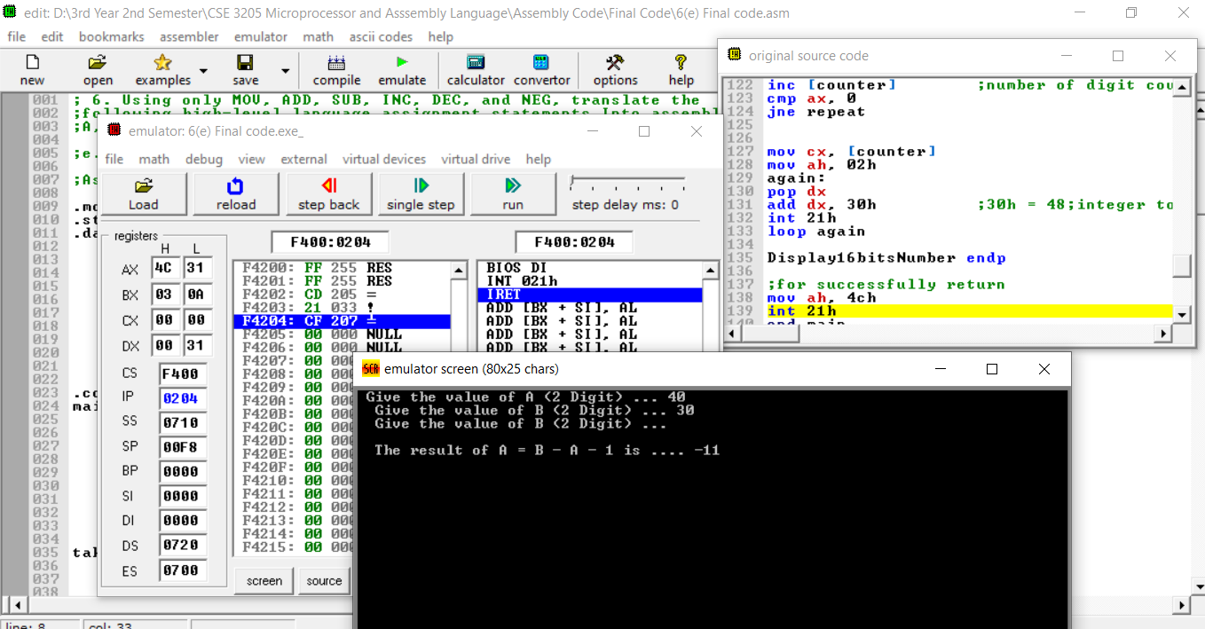

**;7. Write instructions (not a complete program) to do the following.**

**;a. Read a character, and display it at the next position on the same line**

.model small

.stack 100h

.data

msg1 dw ' Enter a character .... $'

.code

main proc

mov ax, @data

mov ds, ax

;print msg1

mov dx, offset msg1

mov ah, 9

int 21h

;input a character

mov ah, 01h

int 21h

;output a single char

mov dl, al

mov ah, 2 ;must give the ah (ax, al will not work)

int 21h

;to execute from ah register

mov ah, 4ch

int 21h

main endp

end main

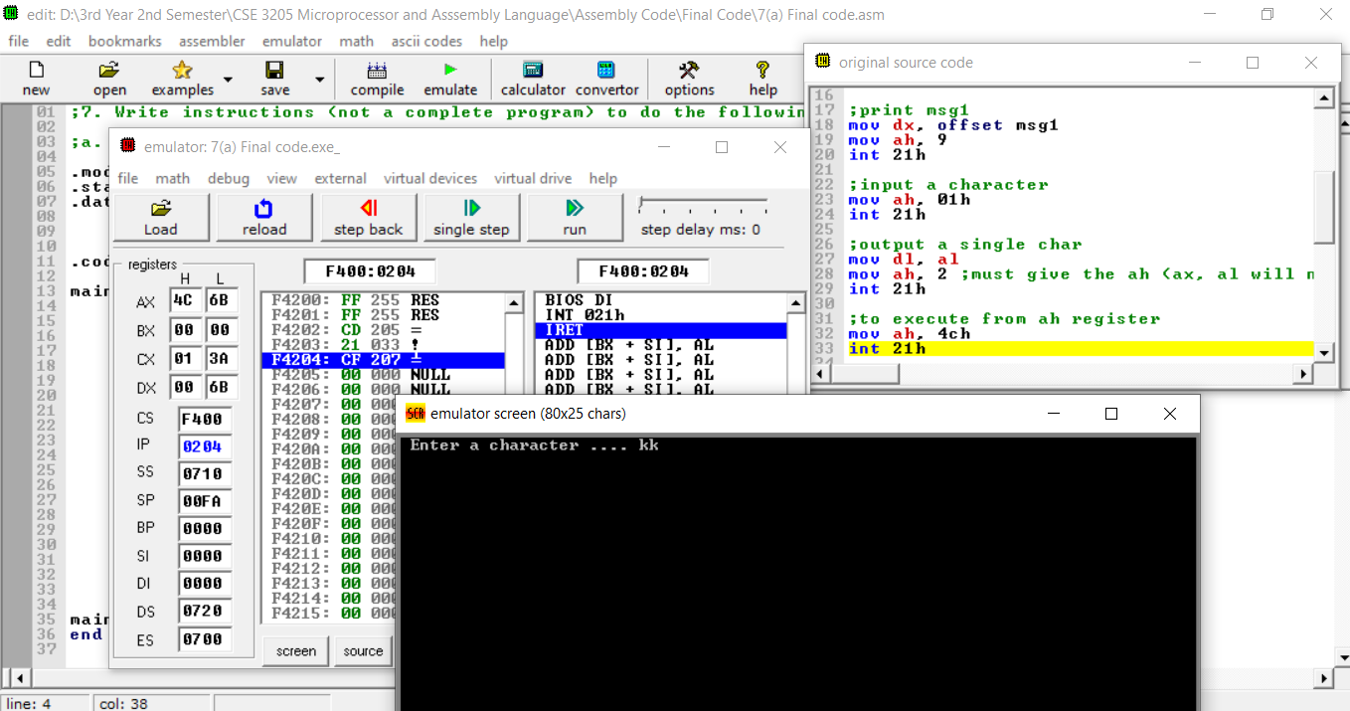

**;7. Write instructions (not a complete program) to do the following.**

**;b. Read an uppercase letter (omit error checking), and display it at the next position on the same line in lower case.**

.model small

.stack 100h

.data

msg1 dw ' Ener a uppercase letter .... $'

.code

main proc

mov ax, @data

mov ds, ax

;print msg1

mov dx, offset msg1

mov ah, 9

int 21h

;input a character

mov ah, 01h

int 21h

;output a single char

add al, 32 ; a - A = 97 - 65 = 32

mov dl, al

mov ah, 2 ;must give the ah (ax, al will not work)

int 21h

;to execute from ah register

mov ah, 4ch

int 21h

main endp

end main

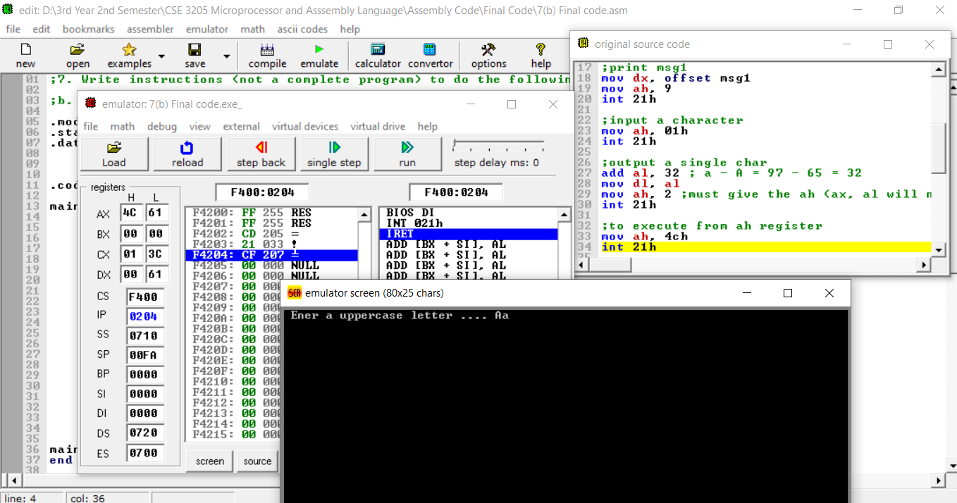

**;8.Write a program to (a) display a "?", (b) read two decimal digits**

**;whose sum "is less than 10, (c) display them and their sum on the**

**;next line, with an appropriate message.**

**;Sample execution:**

**;?27**

**;THE SUM OF 2 AND 7 IS 9**

.model small

.stack 100h

.data

msg1 dw ' ?$'

msg2 dw 13, 10, 'THE SUM OF $'

msg3 dw ' AND $'

msg4 dw ' IS $'

sum db 0

.code

main proc

;for access data directly from Data Segment

mov ax, @data

mov ds, ax

;print the msg1

mov dx, offset msg1 ;same as -- lea dx, msg1

mov ah, 9

int 21h

;******************** INPUT ********************************

;input first digit

mov ah, 1

int 21h

mov ch, al ;cx = ch cl ;store the first digit

;= 02

add sum, al

;input second digit

mov ah, 1

int 21h

mov cl, al ;cx = ch cl ;store the second digit

;= 02 07

add sum, al

;******************** OUTPUT *******************************

;print the msg2

mov dx, offset msg2

mov ah, 9

int 21h

;print the first digit

mov dl, ch

mov ah, 2

int 21h

;print the msg3

mov dx, offset msg3

mov ah, 9

int 21h

;print the second digit

mov dl, cl

mov ah, 2

int 21h

;print the msg4

mov dx, offset msg4

mov ah, 9

int 21h

;print the sum

sub sum, 48 ;maintain the ASCII value

mov dl, sum

mov ah, 2

int 21h

;to execute from ah register

mov ah, 4ch

int 21h

main endp

end main

